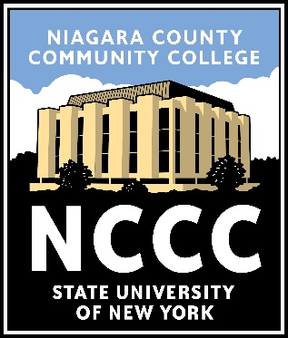
NIAGARA COUNTY COMMUNITY COLLEGE
Computer Information Systems, A.S.

Overview
The computing field is projected to grow faster than any other field by 2026, according to the US Bureau of Labor Statistics. The demand for individuals with experience in software, hardware, data and networks increases daily as all organizations rely on computer and information technology. Our program prepares students with both problem solving and technical skills needed to assist organizations in conducting business and operating more efficiently.

Designed for transfer into a 4-year institution.

Careers
Careers related to your program of study:
• Applications Programmer
• Database Administrator
• Network Administrator
• Information Systems Specialist
• Information Technology Specialist
• Systems Analyst

Some careers may require more
specialized education.

Contact
Program Coordinator
Laura Scarpelli
716-614-6876
lscarpelli@niagaracc.suny.edu

Division
Business & STEM
716-614-6410

Visit full catalog for specific course
offerings for each semester:
www.niagaracc.suny.edu/programs/cis

Program Requirements
First Semester Credits
CIS 119 - Introduction to Computer Systems 3
CPS 120 - Computer Science I 4
ENG 101 - Writing I 3
MAT 110 - Intermediate or Higher Gen Ed Math Elective 3/4
___ ___ - General Education Elective (HUMN, SOCS, ARTS, USCV, GLBL or WLNG) 3
Total Credit Hours: 16/17 Cr.

Second Semester
CPS 130 - Computer Science II 4
ENG 102 - Writing II & Introduction to Literature OR
ENG 103 - Writing for STEM 3
MAT 164 - Introduction to Statistics 3
___ ___ - General Education Elective (HUMN, SOCS, ARTS, USCV, GLBL or WLNG) 3
___ ___ - General Education Elective (HUMN, SOCS, ARTS, USCV, GLBL or WLNG) 3
___ ___ - Health/Physical Education Elective 1
Total Credit Hours: 17 Cr.

Third Semester
ACC 116 - Financial Accounting 3
CIS/CPS 200-level Elective 3
CIS/CPS 200-level Elective 3
___ ___ - Natural Science & Scientific Reasoning General Education Elective 3
___ ___ - Health/Physical Education Elective 1
BUS 229 - Business Communications OR
SPE 101 - Speech Communication OR
SPE 102 - Public Speaking OR
SPE 103 - Interpersonal Communication 3
Total Credit Hours: 16 Cr.

Fourth Semester
ACC 117 - Managerial Accounting 3
___ ___ - CIS/CPS 200-level Elective 3
___ ___ - CIS/CPS 200-level or NET Elective 3
___ ___ - Diversity: Equity, Inclusion & Social Justice General Education Elective (DVRS) 3
___ ___ - Free Elective 3
Total Credit Hours: 15 Cr.

